**Facial Emotion Recognition of Students using Convolutional Neural Network**

**Software requirements**

**• Programming Language : Python**

**• Packages : Numpy,Matplotlib,SKlearn, Pandas, Tflearn, Tensorflow, cv2**

**• Tool : Python 3.7**

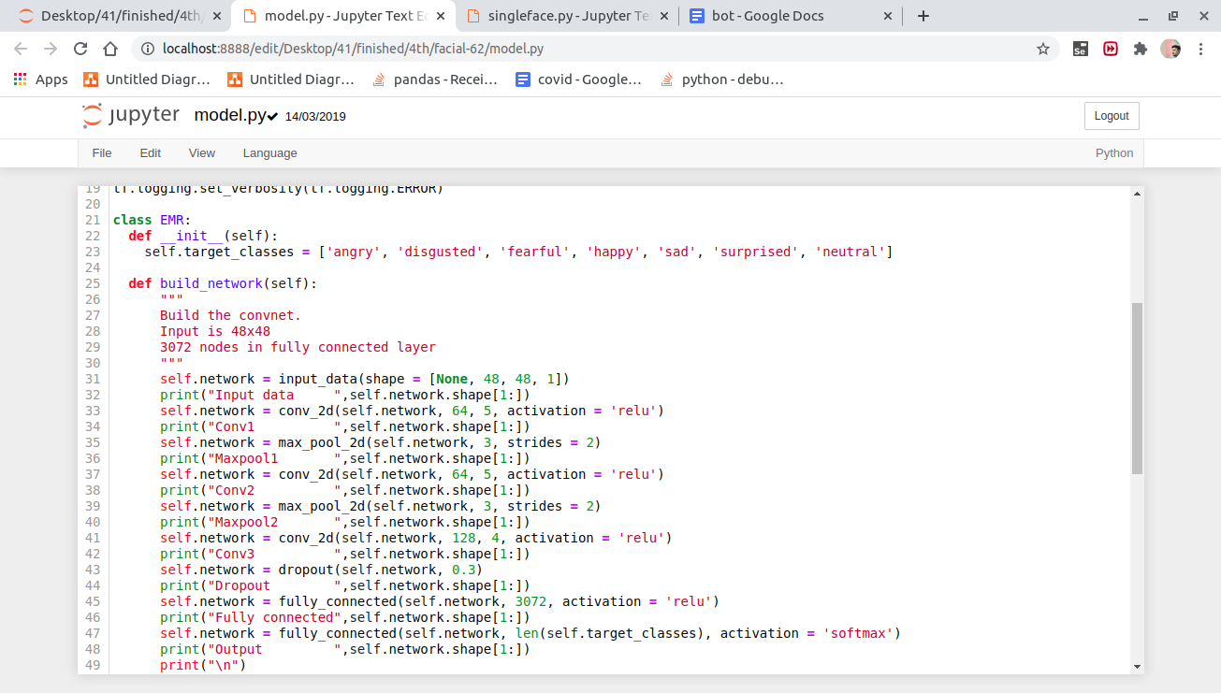

**Class EMR function is used for modelling the image file which was recorded to webcam,**

**Each and every frame as been resized to 48x48 and placed in modelling network for analyzing and predicting the emotion of the given frame with emotions labels**

**['angry', 'disgusted', 'fearful', 'happy', 'sad', 'surprised', 'neutral'] and based on the emotion labels and emoji will also display which was stored in the folder.**

**In cmd- python singleface.py**

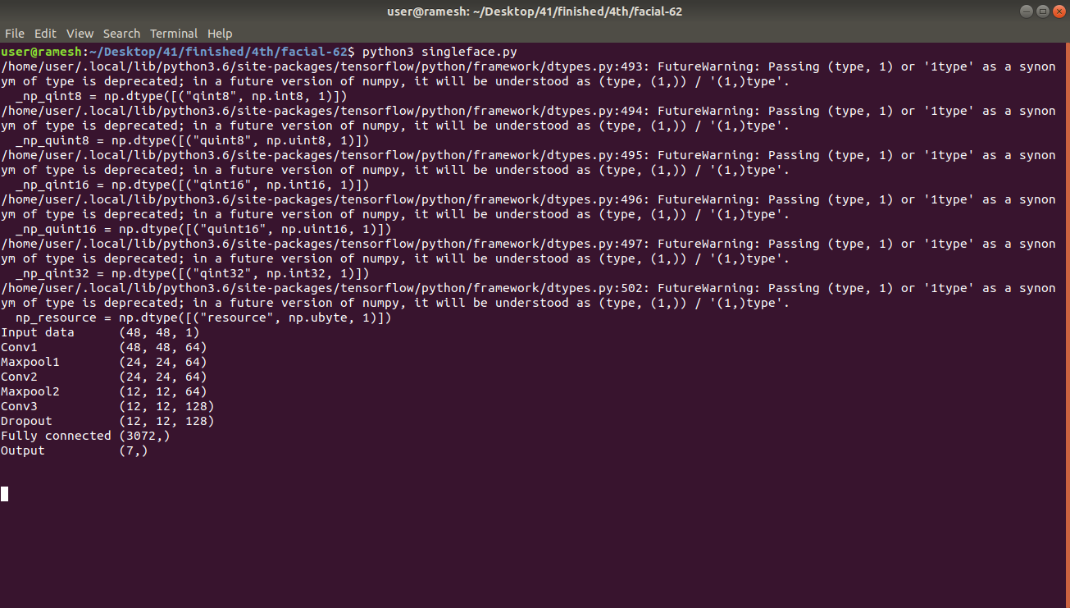

**Result**

